RESERVATION FORM for

CAREER-EU 2011 CONFERENCE 27/04-01/05/2011
Eurorean Assosiation of Career Guidance (EACG)

Please send the duly filled- in reservation form ether by fax or by e-mail to the following contact person:
Mrs. Karagianni Lia (group2_ai@classicalhotels.com)
With cc to eracon11@ucy.ac.cy
(In house reservation phone: +30 210 52 05435/ fax for sending the reservation forms for all hotels 0030 210 5225521)
You are kindly requested to send your booking form the latest till 10/03/2011, after that date confirmation of the reservations will be subject to hotels’ availability.
Please note that each reservation form must be used only from one participant

You are also kindly requested to copy your reservation form to career.eu@ucy.ac.cy

HOTELS:

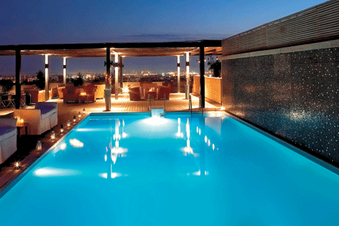
Athens Imperial is an impressive deluxe hotel and it is situated in Karaiskaki Square from where there is easy access to all areas within Athens and outside, as it is just minutes away from Athens Metro Station, Highways. The Athens Imperial is equally convenient for business or leisure as it is located within the historical centre of the city. The hotel offers a unique conference space and banquet facilities, accommodating up to 1.400 persons.

1, Achilleos & Meg. Alexandrou, Karaiskaki Square

104 37 - Athens

Greece
Tel: +30 210 5205435
Room rate per night:
Single: 90.00 Euro including taxes (currently 11,55%) & American Buffet breakfast.
Double: 105.00 Euro including taxes (currently 11,55%) & American Buffet breakfast.
Triple: 130.00 Euro including taxes (currently 11,55%) & American Buffet breakfast.
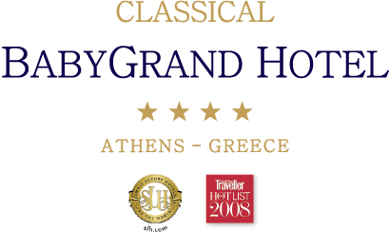
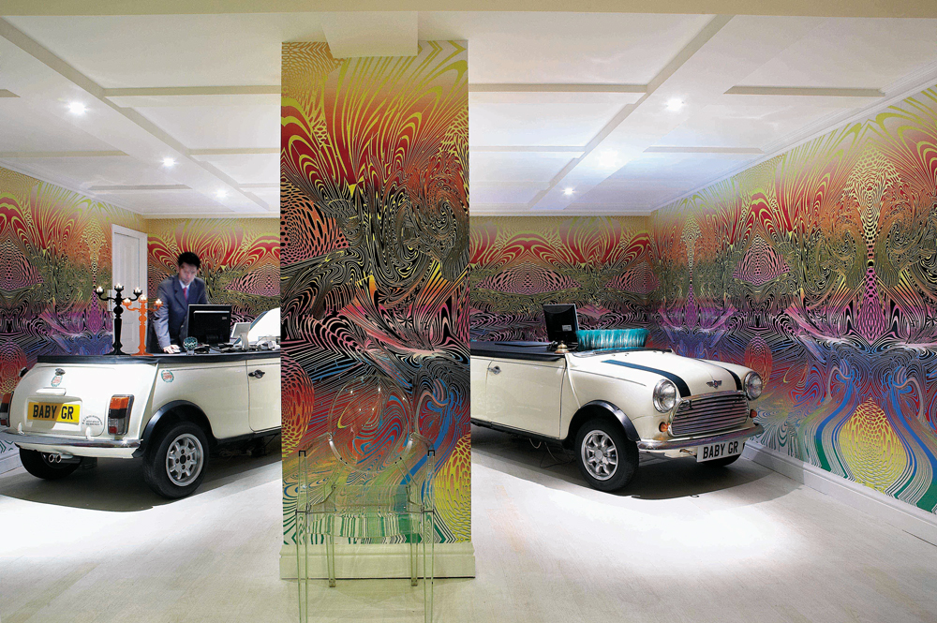

Baby Grand is an inviting 5-star boutique hotel located just a few minutes from Omonia Square and its shopping centre, is the ideal location for those seeking a historic, traditional and modern destination.

65, Athinas str, Kotzia Square

105 51 - Athens

Greece

Tel: +30 210 3250900
Room rate per night:
Single: 75.00 Euro including taxes (currently 11,55%) & American Buffet breakfast.
Double: 90.00 Euro including taxes (currently 11,55%) & American Buffet breakfast.
Triple: 115.00 Euro including taxes (currently 11,55%) & American Buffet breakfast.

GUEST INFORMATION:

Mr. ___ Mrs.___ FIRST NAME: _______________ LAST NAME:_______________

No. of fax for confirmation: __________________
No. of telephone for details: __________________
ROOM RESERVATION:
Hotel of your preference: _______________________
Arrival date: ________________ Departure date: ________________
Nr. Of nights _________ Arrival time at Athens airport: ________________

Type of Room: ( ) single room ( ) double room ( ) triple room

Payment Details:

Credit Card Type: _________________________

Credit Card number:______________________________ Expiring date:_______

CVV digits (3 last digits on the back of the credit card) _____________

A credit card number is required in order to guarantee each reservation and will be charged only in case of cancellation/non show.

BILLING INFORMATION/CANCELLATION POLICY

The hotel reservation is only guaranteed if the hotel receives a personal & valid credit card with expiry date, which should be presented upon check in.

- In case of cancellation between confirmation of the booking – 20 days prior to client’s arrival, no cancellation fees will be applied.

- In case of cancellation between 19-5 days prior to client’s arrival, 1 night’s cancellation fees will be applied.

- In case of cancellation between 4 days prior to client’s arrival up to the arrival date or in case of non-show or in case of early departure, cancellation fees for the whole stay will be applied.

- In case of GTS Systems (Utell, Pegasus etc.) the prices and reservations are not acceptable

SIGNATURE: .................................................................

Sales Department Athens Imperial & Baby Grand
Achilleos & 2-6 M. Alexandrou str. Karaiskaki Square, 10437 Athens
Tel. (+30) 210 5205430 Fax. (+30) 210 5225521 e-mail: sales_ai@classicalhotels.com
www.classicalhotels.com

